­­

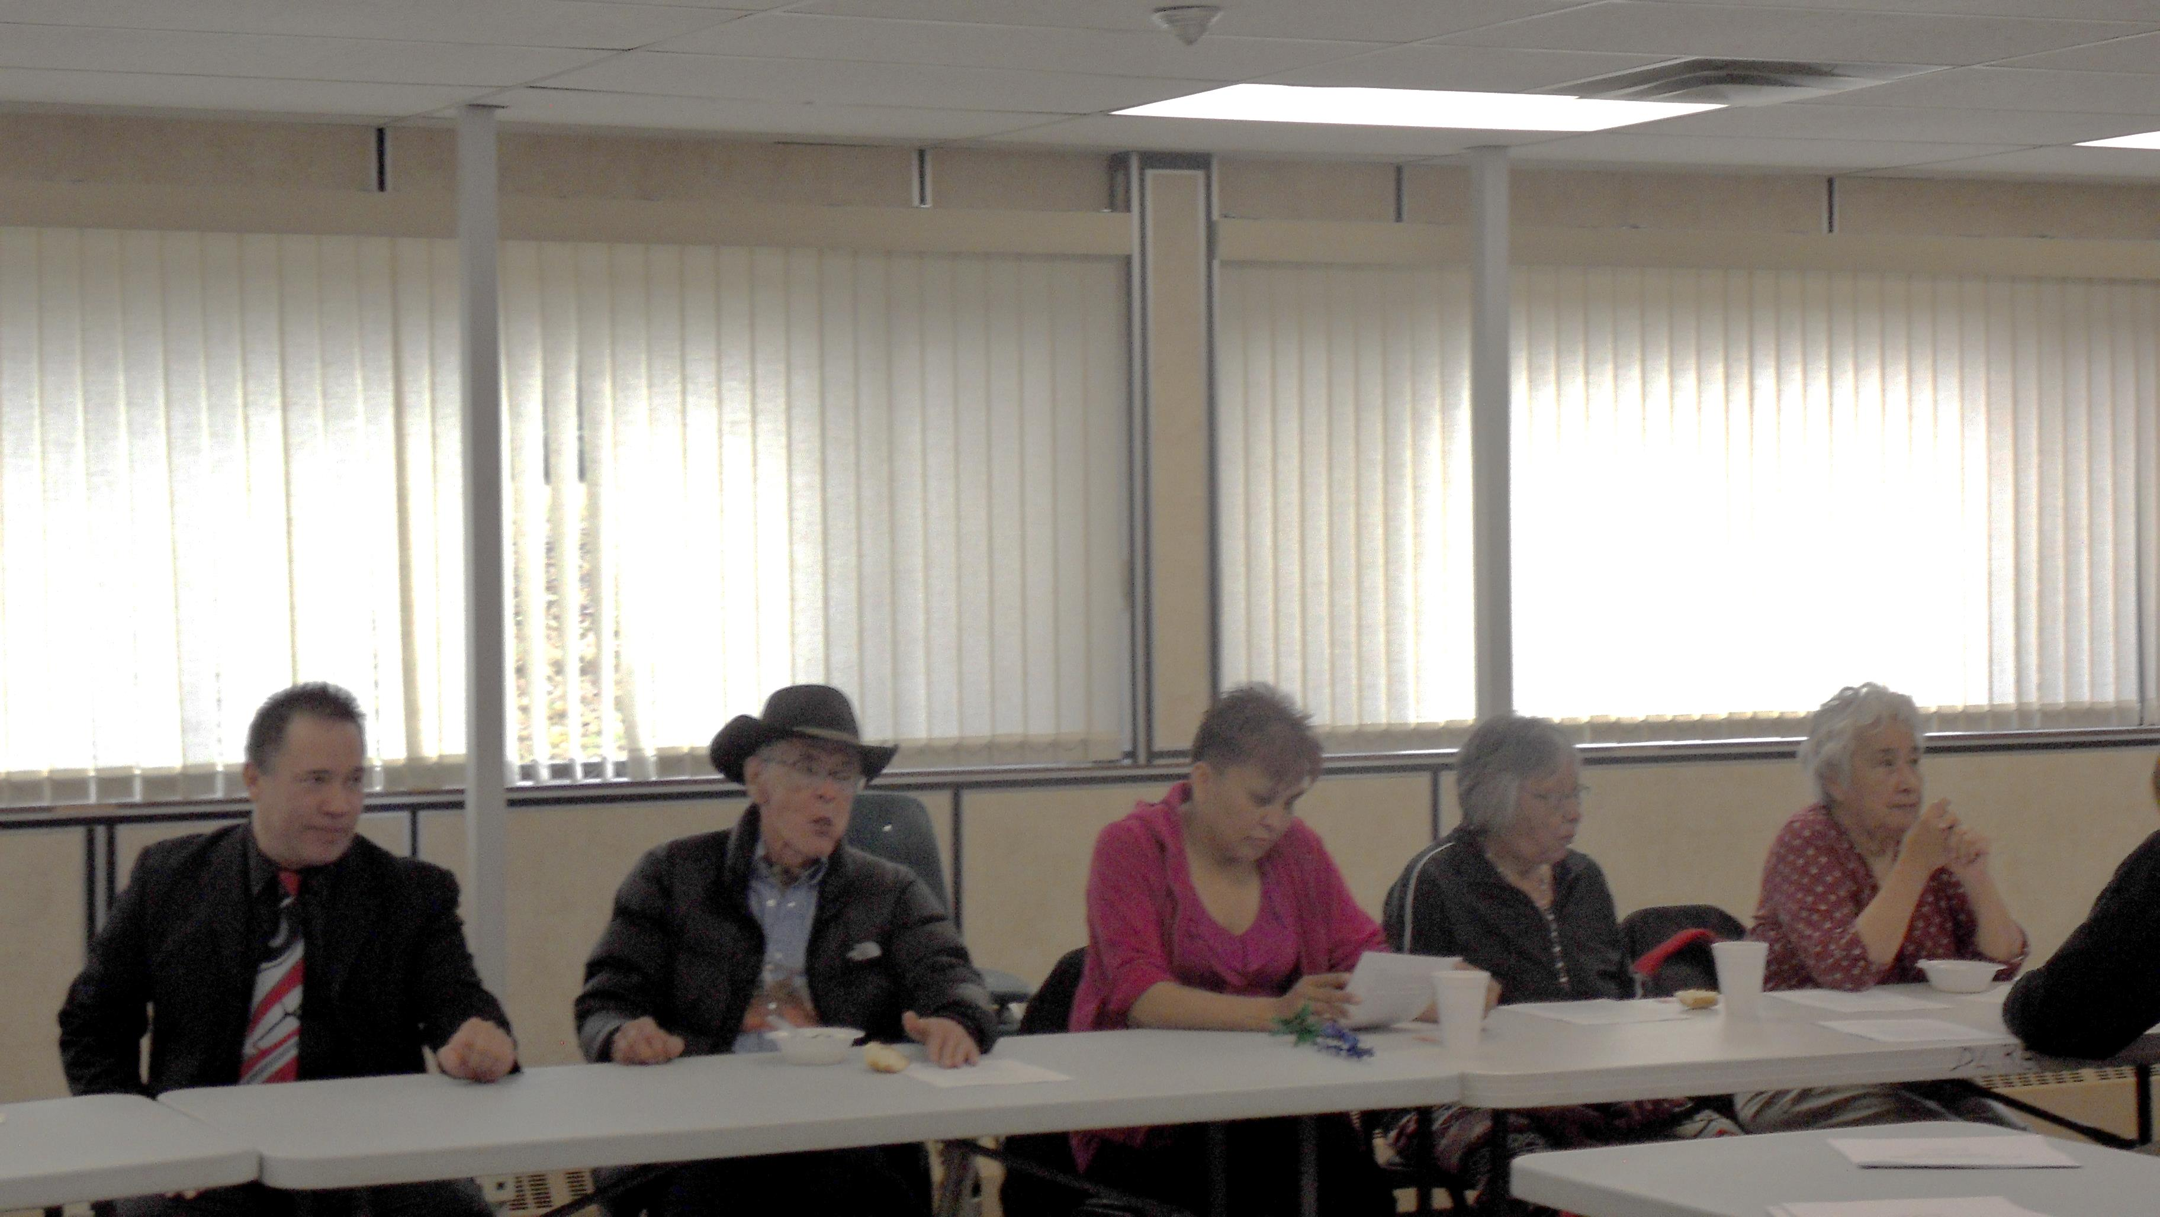

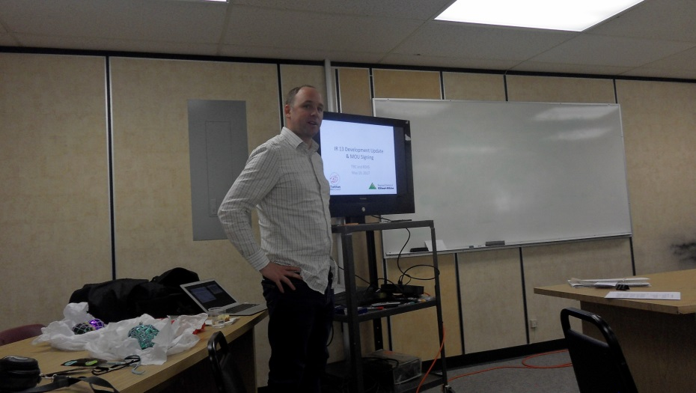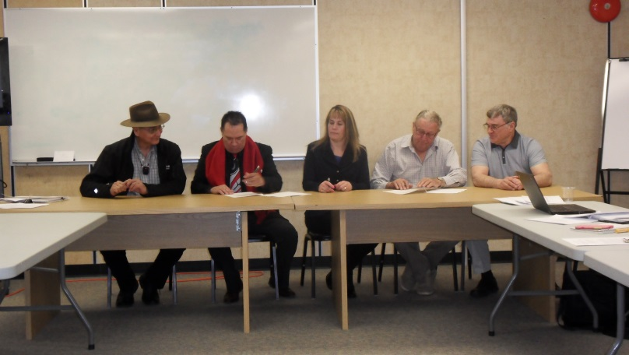

There was a meeting held at the School board Office in Dease Lake on May 19th, 2017. Below is a brief description of what the meeting was about.

The signing of the Memorandum of Understanding occurred as a result of decisions to continue exploring ways to develop IR 13 (Parcel A). The MOU serves as a document to open and encourage discussions with the Regional District of Kitimat Stikine.

By working collaboratively with RDKS, there will be opportunities to share information, proactively apply for funding opportunities and share costs for potential infrastructure improvement.  Ensuring an open and ongoing dialogue will help grow government-to-government relations, and promote efficiencies between the Tahltan and RDKS.  While originally envisioned to assist in the development of IR 13 around Dease Lake, the scope of the MOU can include discussions and implementation strategies for other services such as RCMP, MCFD and fire safety extending to Telegraph Creek and its related Electoral Area.

All in all, the MOU is a first step to developing an ongoing and sustainable relationship, which may eventually lead to agreement for more efficient provision and the sharing of information, services and opportunities.

IR# 13 Update Meeting

Memorandum of Understanding

­